B’s FAB Lighted Mirror Kit Installation Instructions

KIT INCLUDES
- Two bolts – part #1
- Two washers – part #2
- Two spacer cups – part #3, NOTE; Cup recess faces up
- Two Adapter brackets – part #4, NOTE; These are side specific, Right & Left
- Two Lighted mirrors – part #5

TOOLS REQUIRED FOR INSTALLATION
- 10 & 15 mm sockets and a ratchet
- 8mm Allen wrench
- Small screwdriver or pick
- Wiring tools

- Remove your OEM mirror from the mirror mount, using a small screwdriver or pick to remove the rubber plug from the top, then use an 8mm allen and a 15mm socket remove the bolt and hardware holding the mirror to the mount, set all those parts aside as none of them will be reused, see pic #1 below. Leave mirror mount in place on the machine
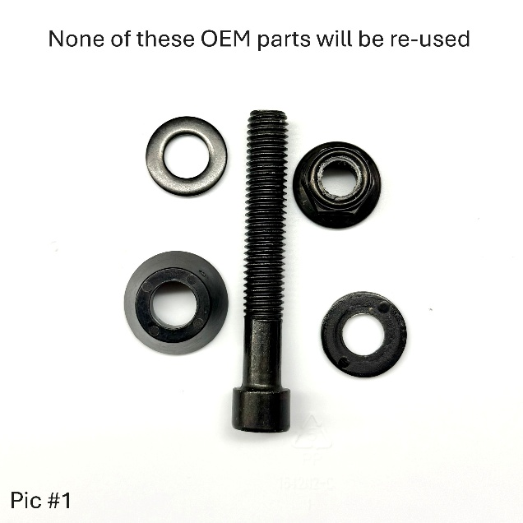

- Your new lighted mirror kit is pre-assembled but will have to be unassembled for installation so make note of the order of the parts prior to taking it apart, see pic #2
- In the order shown in pic #2 assemble your new lighted mirror onto your existing OEM mirror mount. The Adapter brackets are side specific & the cup washer has a recess which faces up when you put it into the OEM mirror mount.
- Tighten the bolt a little at a time until you get enough friction that the mirror won’t move while riding but not so tight it won’t fold in if you hit something with it, sneak up on just the right amount of tightness by going just a little at a time – DO NOT OVERTIGHTEN!
- Wire up your mirrors and you are done! Wire colors red is positive, black is ground and yellow is for the amber running / turn signal lights
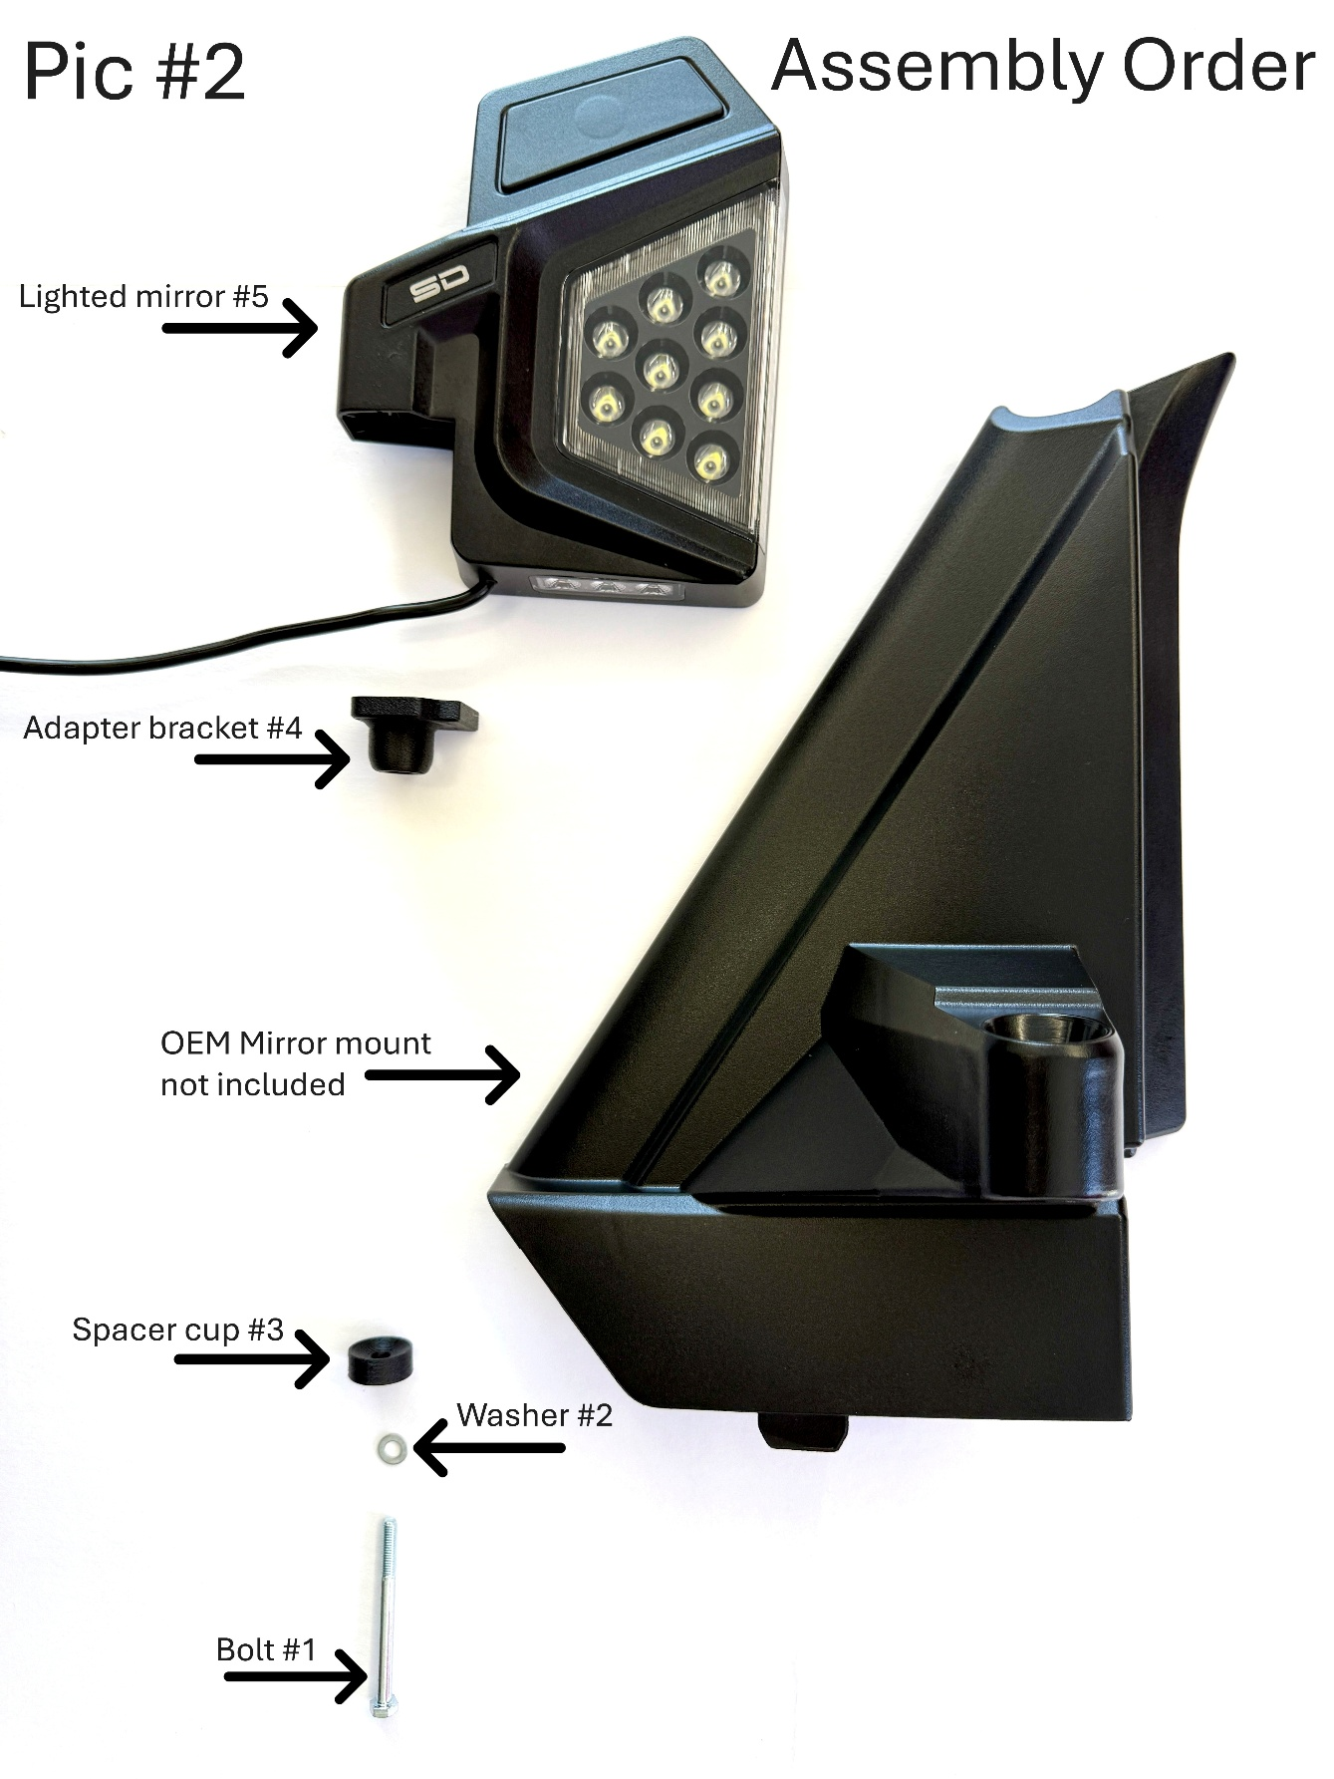

We really appreciate your business, and your satisfaction is very important to us. If you are not satisfied, we ask you please contact us so can resolve any issues or concerns you may have.
Web – www.bsfabutv.com
Email – info@bsfabutv.com
Phone – 1-888-779-1497

