Instructions - Polaris Xpedition Bedside Milwaukee Packout Mounting System

Packing List:
- 1 - Milwaukee packout mounting plate
- 2 – Small mounting tabs
- 2 – Large mounting tabs
- 4 – ¼-20 flange head bolts
- 2 – M8 flange head bolts
- 2 – B’s FAB Polaris Lock & Ride MAX Bed Rail Nuts
- 2 – Plastic push pins

Tools Required:
- Drill with 5/16" drill bit
- Ratchet or impact driver
- 13mm socket
- 3/8” socket

- Loosely assemble the tabs onto the mounting plate using the ¼-20 flange head bolts, you will see there are two threaded inserts on the top of the mounting plate. The top holes are used for the XP models and the lower holes are used for the ADV models, see pic below.

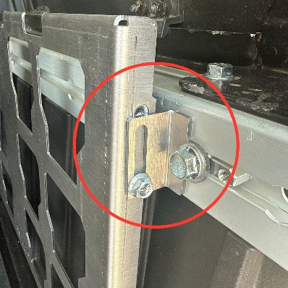

- Install the Lock & Ride MAX Bed Rail Nuts on the backside of the large tab using the M8 flange head bolts

- Align the forward Lock & Ride MAX Bed Rail Nut with one of the openings in the bed rail and slide it forward and while doing so align the rear Lock & Ride MAX Bed Rail Nut with one of the openings in the bed rail so that the mount is now loosely hanging in the bed rail

- Adjust the mounting plate fore and aft where you want it being sure both lower tabs will land flat in the recess of the bed corrugations (see pic below) and tighten both M8 flange head bolts and both ¼-20 flange head bolts on the upper tab.

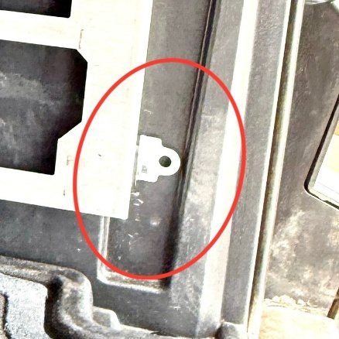

- Using a 5/16” drill bit drill through the plastic bedside where both lower tabs are and install the two Plastic push pins and tighten both ¼-20 flange head bolts on both lower tabs and your done.

Thank you for your order! We greatly appreciate your business. Your satisfaction is very important to us. If for any reason you are not satisfied, please contact us so that we can resolve any issues that you may have.
We have taken great care to manufacture, pack and ship your order as quickly and professionally as possible. When you are happy with your order, please let others know by leaving us a 5 star rating on our website, positive feedback on eBay, commenting on our Facebook page or posting on the Polaris General forum and Facebook groups. This lets us know that you, our valued customers are happy with our product and services and this also helps others in making the right decisions on whom to buy from.

Web – www.bsfabutv.com
Email – info@bsfabutv.com
Phone – 602-577-0460

