Polaris Xpedition License Plate Bracket Installation Instructions

- Attach LED Light facing the bracket like in the photo below using the 2 supplied 6-32 Phillips head screws.

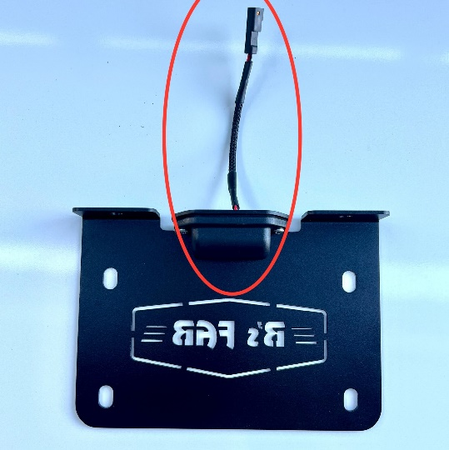

- Remove the two T-25 Torx screws holding the left side taillight in, see pic below. Unplug the factory wiring harness from the taillight, plug in supplied wiring harness into taillight and factory wiring harness. Fish the License Plate wire down and through the bottom, following the factory harness through the hole. Once you have pulled the wire out the bottom, put the taillight back in place and tighten Torx screws.

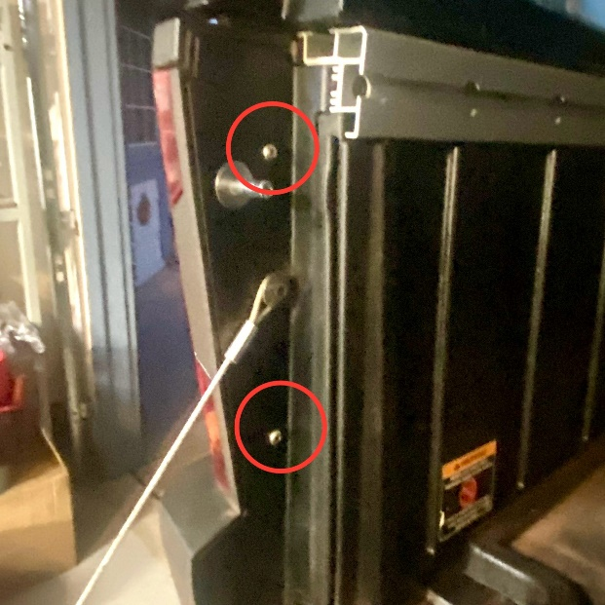

- Connect the wiring harness to the LED Light pigtail on the bracket and position bracket in desired location on the metal flange under the bed on drivers’ side being sure it’s not too close to the exhaust. Mark the mounting holes using the bracket as a template and drill two holes using a 1/4" or slightly larger drill bit and deburr.

IMPORTANT NOTE: XP owners should be mindful of the exhaust / muffler and position the License Plate bracket to not interfere when tilting the bed.

- Attach License Plate Bracket with supplied ¼” hardware and ahead and route wire and zip tie to factory harness under bed. See pics below.

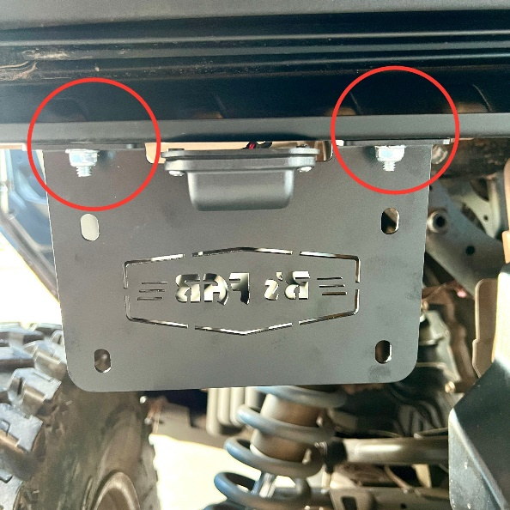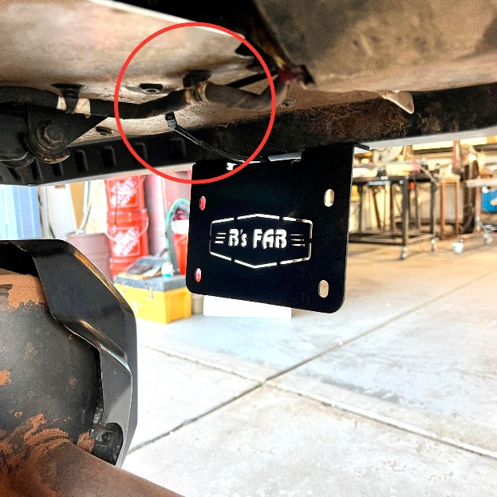

- You are now ready to install your License Plate using the remaining ¼” hardware and your done!

B’s Fab would like to thank you for your purchase! We greatly appreciate your business. Your satisfaction is very important to us. If for any reason you are not satisfied, please contact us so that we can resolve any issues that you may have.

We have taken great care to design, manufacture, pack and ship your order as quickly and professionally as possible. When you are happy with your order, please let others know by leaving us positive feedback on all your favorite social media groups. This lets us know that you, our valued customer, is happy with our product and services provided and helps others in making decisions on whom to order from.

We always welcome your suggestions on how to improve our products and or services.

Again thank you for the purchase it truly is highly appreciated!

Web – www.bsfabutv.com
Email – info@bsfabutv.com
Phone – 1-888-779-1497
Facebook – https://www.facebook.com/bsfabutv

B’s FAB
20403 N Lake Pleasant Rd.
Suite #117-485
Peoria, Arizona 85382

