B’s FAB 2021 and Newer Polaris General Automatic Reverse Light Kit
Installation Instructions

- Mount the lights to the flange on the bottom outside edges of the bed by removing the existing factory bolt and reusing it to mount the new light brackets. Note there are RH and LH brackets.

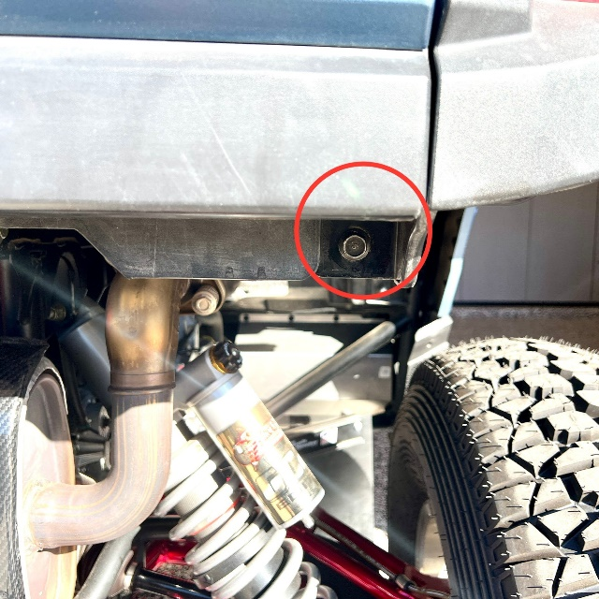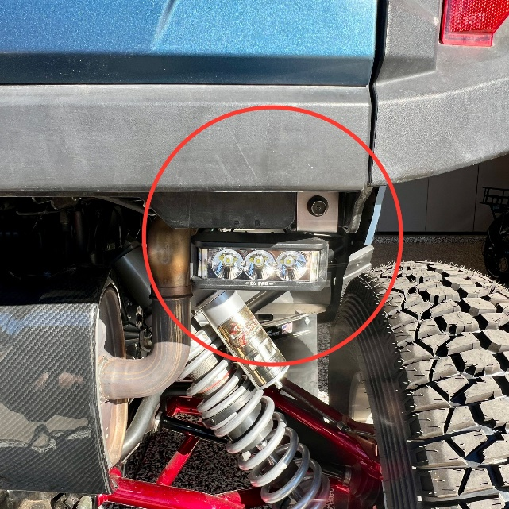

- Mount your relay and ground wire as shown below with the wires exiting the relay towards the front of the machine. Then route your wires to the back lights securing them onto the frame with supplied zip ties.

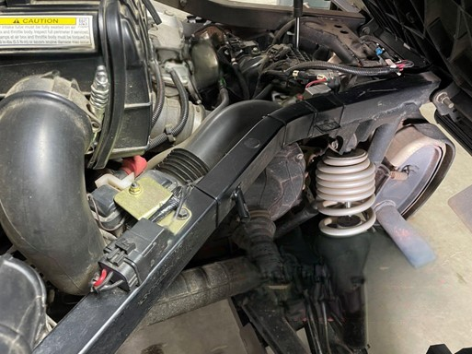
Please note: Wires from Relay should be facing forward towards the cab.
Relay and Ground wire will use this factory bolt to secure both.
Wie Harness is installed along the inside of the Frame Rail. Use supplied Zip Ties to secure.

Page 1

- The ECU is found on the rear wall on the driver’s side. There is a cover that you remove to reveal the ECU. The ECU is held in with four T25 torx screws, remove those so you can access the plug.
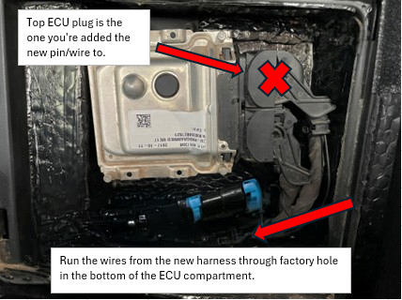

5. Cut the zip tie on the end of the plug that holds the wire to the plastic cap. There is a small tab on the front side you will need to gently push in and you can tip the upper cover towards the wires and it will pop off.
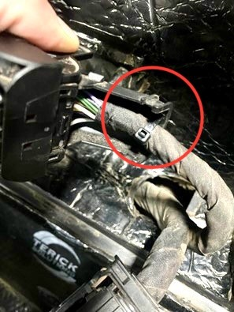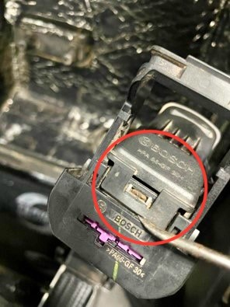

Page 2
6. Using a small pic or small screwdriver, poke it into the holes in the plug housing to push out the purple retaining clip.
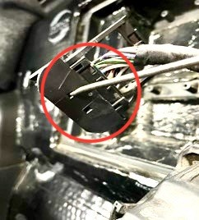
7. Once you have pushed it out a bit now you can and pull it all the way out keeping note of the direction removed. Important note remember the direction removed for reinstalling it later.
.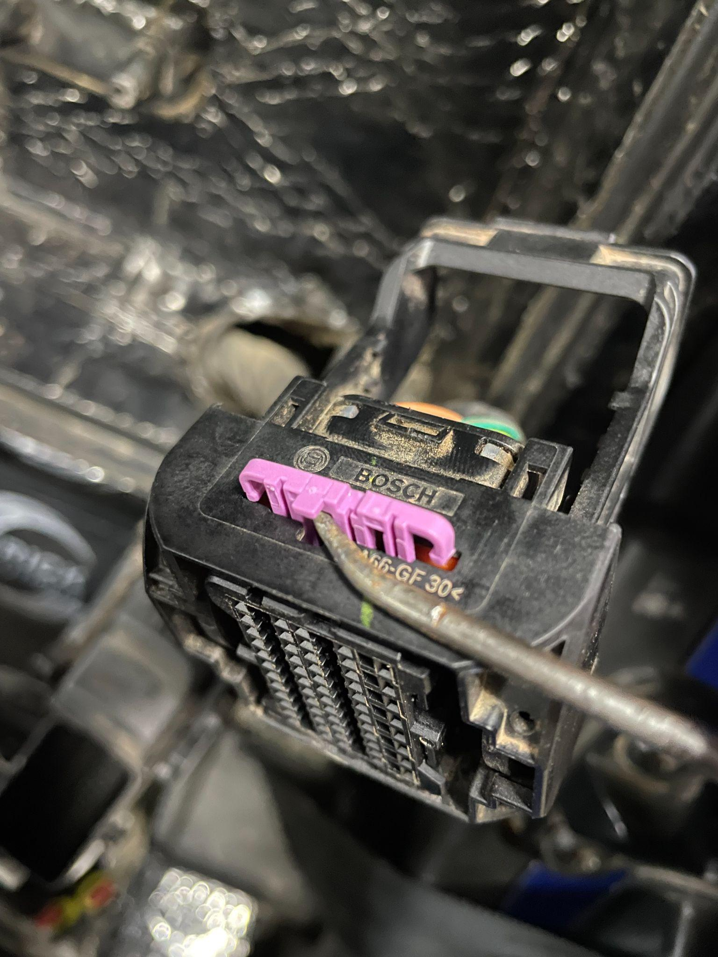
8. Next step is to remove the Blue and or Purple Dummy Pin from the housing, using needle nose pliers grab dummy pin and pull it out of the connector.
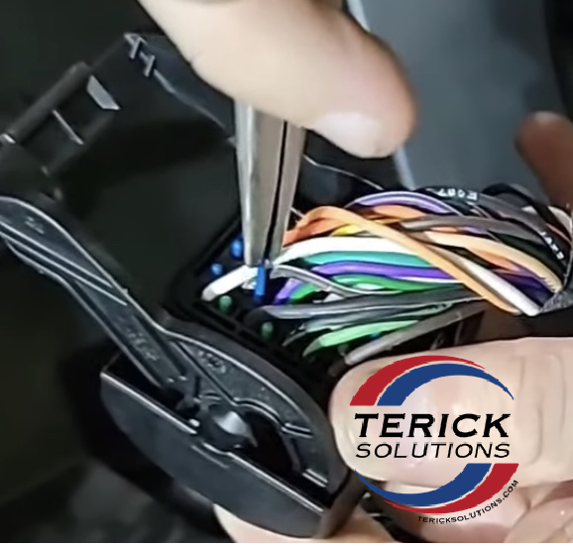
Page 3

9. Locate Pin location #45. You locate the pin numbers on the back side of the connector. Positions #44 and #46 are being used already and should help locating it easier.
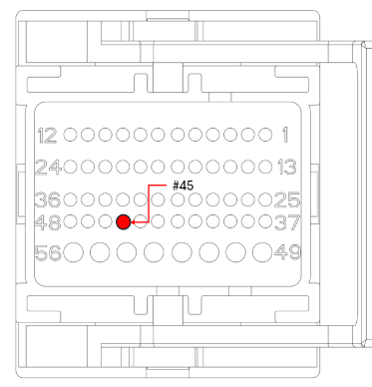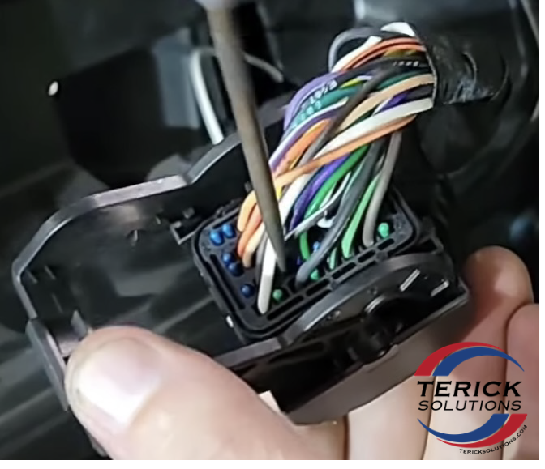

10. Install the black wire into position #45 from the kit. Install the wire same way the dummy pin you removed came out. Be sure the pin / wire is seated properly and secure in the plug.

11. Next to verify you installed the pin / wire correctly, reinstall the Purple Clip back into the plug. If you inserted the pin / wire correctly, you should not be able to move pin / wire you just installed. However, if it does move, simply remove the Purple Clip and verify the pin / wire is inserted completely and locked into the connector. Replace purple clip.

12. Reassemble the cap and connector, do not forget to replace the zip tie you removed originally.

13. Mount the ECU back into the factory location using factory hardware and replace the plastic cover.

14. Route the fused power wire down into the battery compartment and connect it to the positive side of the battery.

We really appreciate everyone’s business; your satisfaction is very important to us! If you are not satisfied, we ask you please contact us so can resolve any issues or concerns you may have.

Web – www.bsfabutv.com
Email – info@bsfabutv.com
Phone – 1-888-779-1497

Page 4

