INSTALLATION INSTRUCTIONS

- Tilt the dump bed, installation will be easier if you undo the lift support so the bed will tip all the way back.

- Place the mount where you want it on the metal tube under the bed on drivers side and attach using two of the supplied self-tapping screws, see picture below.

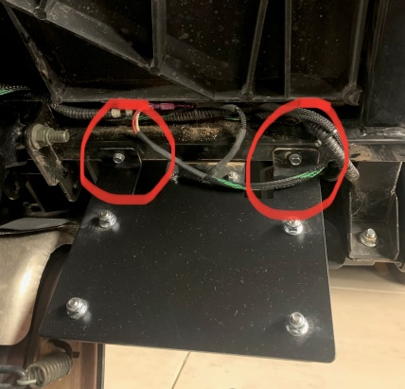

- Carefully route the wiring over to the factory connector mounted on top of the frame, see picture below. Now unplug the factory connector and plug the new license plate wiring into that connector then plug other side of factory connector into that plug. Be sure all wiring is tied up well and doesn’t get pinched when the bed closes. Plug the wiring harness connectors into the pigtail connectors on the backside of the LED light.

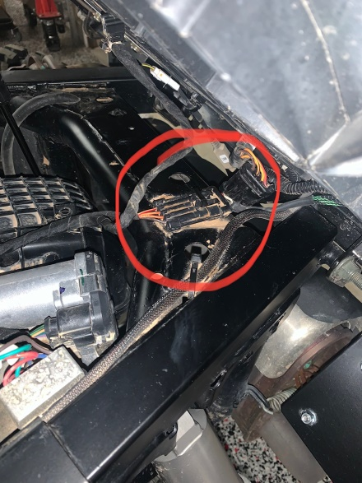

- Re-connect the bed lift support that was disconnected in step 1 and close the bed. Be sure and check that all wiring is tied up well and doesn’t get pinched when bed closes.

- Install third self-tapping screw into tubing as shown in picture below.

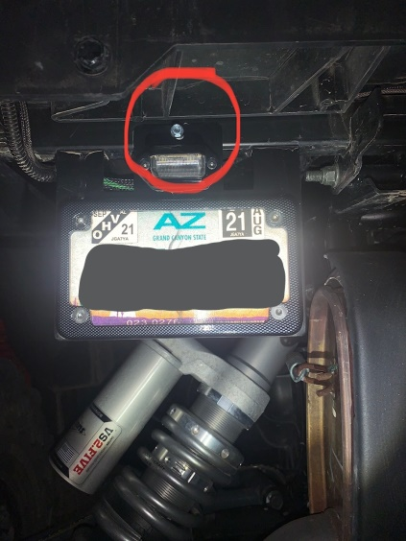

B’s Fab would like to thank you for your order! We greatly appreciate your business. Your satisfaction is very important to us. If for any reason you are not satisfied, please contact us so that we can resolve any issues that you may have.

We have taken great care to design, manufacture, pack and ship your order as quickly and professionally as possible. When you are happy with your order, please let others know by leaving us positive feedback on eBay, commenting on our Facebook page or posting on the forums and in Facebook groups. This lets us know that you, our valued customers are happy with our product and services and this also helps others in making the right decisions on whom to order from.

We always welcome your suggestions on how to improve our products and or services.

Again we thank you for your order!

Web – www.bsfabutv.com
Email – info@bsfabutv.com
Phone – 602-577-0460
Facebook – https://www.facebook.com/tigweldinginphoenix/?modal=admin_todo_tour

B’s Fab
20403 N Lake Pleasant Rd.
Suite #117-485
Peoria, Arizona 85382

