Instructions for B’s FAB Battery Tray Kit

This battery tray kit was designed for the Odyssey Battery #ODS-AGM42MJA / Old part #PC1200LMJT or the Full Throttle Battery Part #FT560L

- Remove old battery and discard the upper battery hold down strap. This is a good time to clean all your terminals and connections with water & baking soda to get rid of any corrosion.

- Remove the brake line retaining clip from the upper hole in the pic below and then drill out both of the holes circled in red to 5/16”.

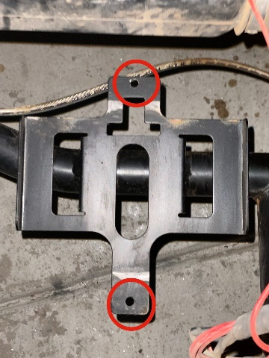

- Set the bottom section of your new battery tray onto the bottom section of the factory battery tray with the threaded inserts towards you and taller side of battery tray away from you, see pic below and bolt it down through the holes that were just drilled out to 5/16” using the flange head bolts & nuts provided in your kit.

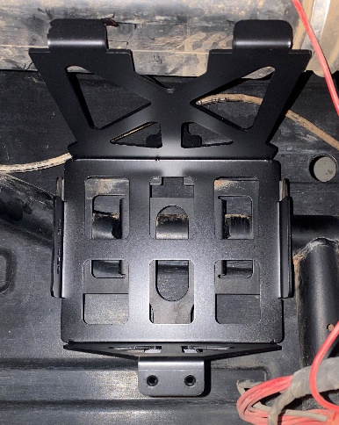

- Using the new brake line clip included in your kit re-attached the brake line to the hole provided on the new battery box. Now install your new Odyssey or Full Throttle battery into the battery box and install the battery hold down strap using ¼” flange head bolts provided in your kit and last but not least reattach all your cables & wires.

- Due to slight variances in manufacturing you may or may not need to use some foam tape to keep the battery snug in the tray, if you do need it we suggest putting it on the bottom side of the lid similar to the blue lines in the pic below.

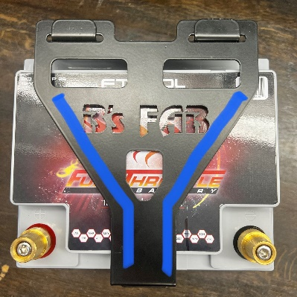

B’s Fab would like to thank you for your order! We greatly appreciate your business and your satisfaction is very important to us. If for any reason you are not satisfied, please contact us so that we can resolve any issues that you may have.

We have taken great care to design, manufacture, pack and ship your order as quickly and professionally as possible. When you are happy with your order, please let others know by leaving us positive feedback on eBay, commenting on our Facebook page or posting on the forums and in Facebook groups. This lets us know that you, our valued customers are happy with our product and services and this also helps others in making the right decisions on whom to order from.

We always welcome your suggestions on how to improve our products and or services.

Again we thank you for your order!



Web – www.bsfabutv.com
Email – info@bsfabutv.com
Phone – 602-577-0460
Facebook – https://www.facebook.com/tigweldinginphoenix/?modal=admin_todo_tour
Instagram - https://instagram.com/bsfabutv

B’s Fab
20403 N Lake Pleasant Rd.
Suite #117-485
Peoria, Arizona 85382

