Instructions for B’s FAB Rechargeable Dome Light Kit

This kit was designed for all Polaris UTV’s that have oval shaped mounting sockets cast in the factory plastic roof.

- Install mounting base on the raised oval socket, using the two T-20 torx screws provided. Important not to overtighten them its just plastic.
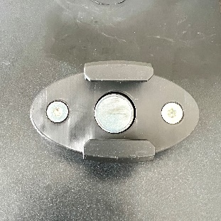

- Using the provided USB cord, charge your new light for approx. 2 hours to get it fully charged.

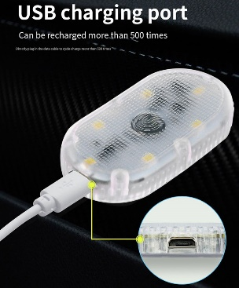

- Once light has a full charge simply slide the light into the mount and your ready to enjoy the ride knowing you got light when you need it.
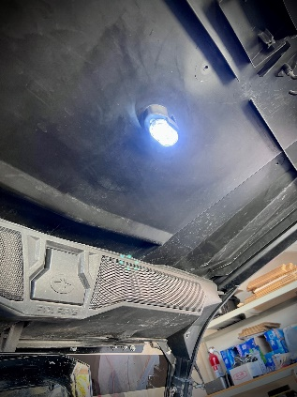

B’s Fab would like to thank you! It’s very important to us, that you know we do appreciate your support for our small business. If not satisfied please reach out and let know what your issues might be.

Customer service is a very top priority for B’s Fab, we’ve done our best to provide all aspects of this. From product support the ordering process, manufacturing to the shipping process. We would appreciate a moment of your time to share your expereinces with others from your favorite social media source or ecommerce site you purchased from.

We welcome all suggestions on how to improve either our products and or services provided to this great community.

Again thank you!

Web – www.bsfabutv.com
Email – info@bsfabutv.com
Phone – 1-888-779-1497

Facebook – https://www.facebook.com/tigweldinginphoenix/?modal=admin_todo_tour
Instagram - https://instagram.com/bsfabutv
YouTube - https://www.youtube.com/@Bsfabutv/playlists

B’s FAB
20403 N Lake Pleasant Rd.
Suite #117-485
Peoria, Arizona 85382

